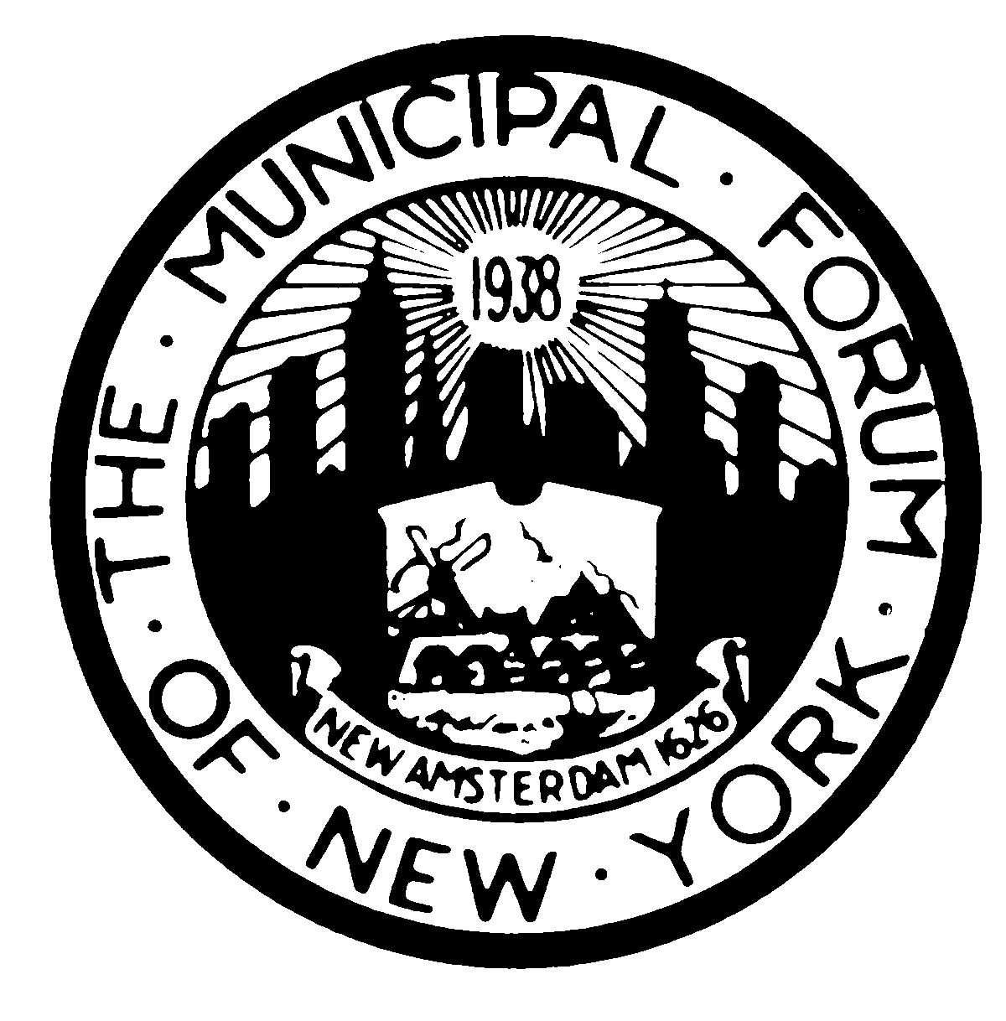 | The Municipal Forum of New York  -Established 1938- www.themunicipalforumofnewyork.org  October 2019  TO: The Membership Committee of the Municipal Forum of NY  I hereby apply for Public Sector Membership in The Municipal Forum of New York. There is no charge for membership.  Individual Public Sector members can attend Municipal Forum luncheons for a cost of $25 per lunch, payable at the time of the lunch.  To order your subscription, please fill out this form and email it (Word format preferred) to gloria.d.boyd@jpmorgan.com and uyen.poh@nortonrosefulbright.com:  Name: _________________________________________  Firm: _________________________________________  Dept.: _________________________________________  Address: _________________________________________  _________________________________________  _________________________________________  Phone: __________________________________________  Email: __________________________________________

