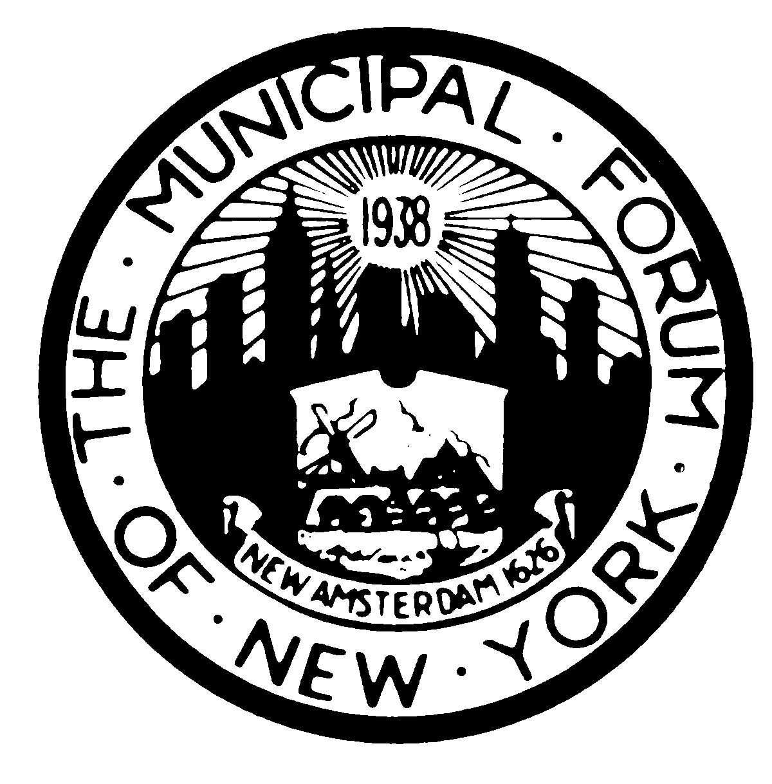 | The Municipal Forum of New York  -Established 1938- www.themunicipalforumofnewyork.org

2019-2020 Corporate Subscription Form

Firm Name: ________________________________________________

Address: ________________________________________________

________________________________________________

Please provide the names and contact information of a primary contact, a secondary contact and an administrative contact for your firm’s membership.

Primary Contact
Name: _____________________________________________
Phone: ______________________________________________
Email: _______________________________________________
Secondary Contact
Name: _____________________________________________
Phone: ______________________________________________
Email: _______________________________________________
Administrative Contact
Name: _____________________________________________
Phone: ______________________________________________
Email: _______________________________________________

Please contact Gloria Boyd or Uyen Poh (gloria.d.boyd@jpmorgan.com and uyen.poh@nortonrosefulbright.com)with questions.

